Name Quang Huynh
Color Green
Date 9/28/2017

Drops on a Penny Lab


Problem: How does soap affect the surface tension of water?
Background: Surface tension is a property of water that involves the molecules “sticking” together at the surface. If you have ever poured a glass of water up and over the top of the glass and seen a “bubble” then you have experienced surface tension. You can measure the strength of the surface tension of a liquid by add drops of the liquid to the surface of penny. The surface tension will cause the drops to create a “dome” as in the picture below. At some point the surface tension will “break” and the water will spill off the penny.
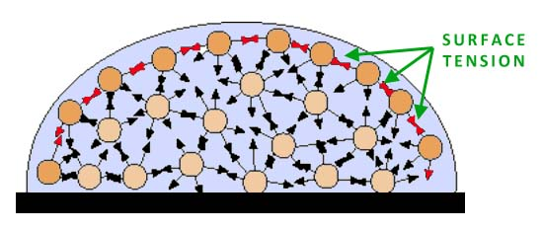
Hypothesis: If I add soap to the water, then the surface tension of the water will decrease(increase or decrease) and I will be able to add less(more or less) drops of liquid on the penny before it spills off.

Independent Variable: The amount of soap

Dependent Variable: number of drops of liquid

Constants: The penny, and the amount of water per drop (tails)

Materials: penny, paper towels, eye dropper, soapy water, tap water
Procedure: Part A
1. Place the penny on paper towel.
2. Use an eye dropper to place drops of TAP water on the penny
(one at a time) until ANY amount of water runs over the edge of the penny.
3. Record the number of drops for that trial in table 1.
4. Repeat steps three more times before calculating your average.
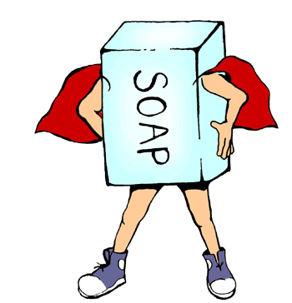
Part B.

1. Place the penny on paper towel.
2. Use an eye dropper to place drops of SOAPY WATER on the penny (one at a time) until ANY amount of water runs over the edge of the penny.
3. Record the number of drops for that trial in table 1.
4. Repeat steps three more times before calculating your average.

Data:
Table 1. Type of liquid Number of Drops That Fit on a Penny
 | Trial 1 | Trial 2 | Trial 3 | Trial 4 | Average
Tap Water | 12 | 19 | 25 | 23 | 20
Soapy Water | 20 | 23 | 26 | 25 | 24

Create a simple bar graph of the AVERAGES of the two types of water. You will only have two bars.
Your x-axis will be labeled with the INDEPENDENT VARIABLE : Type of liquid
Your y-axis will be labeled with the DEPENDENT VARIABLE : Amount of drops on a penny

Data Analysis: Does the type of liquid affect the amount of drops?
Yes, the type of liquid does affect the amount of drops on a penny.

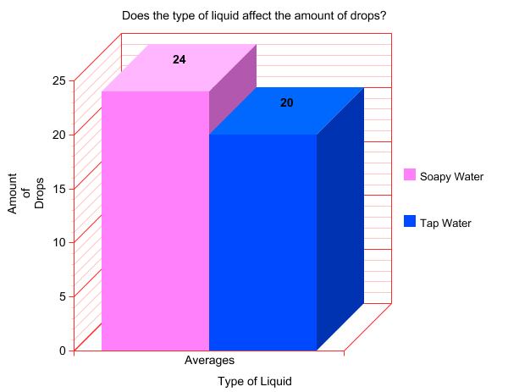

Questions:
- Why were many trials taken and averaged?
So many trials were taken and averaged because of to make sure that there was no
error or miscounting, so therefore we took more than 1 or 2 trials.
Matching
D Independent variable a. The tap water
C Dependent variable b. Same Penny
B One Constant c. The number of drops
A Control Group d. type of water

Conclusion
This lab focused on answering the following problem: Which type of liquid would have more drops on a penny?
In my hypothesis I guessed that the tap water would hold more drops.
The data showed that the soapy water held more drops on a penny.
One possible source of error in this experiment is miscounting, maybe the actual drops on a penny is 20 and you counted 22.

Teacher Notes (do what you’d like…):

Drops On A Penny Lab
Cohesion Water molecules are attracted to other water molecules. The oxygen end of water has a negative charge and the hydrogen end has a positive charge. The hydrogens of one water molecule are attracted to the oxygen from other water molecules. This attractive force is what gives water its cohesive properties.

Surface Tension Surface tension is the name we give to the cohesion of water molecules at the surface of a body of water. The cohesion of water molecules forms a surface "film" or “skin.” Some substances may reduce the cohesive force of water, which will reduce the strength of the surface “skin” of the water.
Use this information to help you answer the questions on
the lab sheet after you have completed the experiment!

Take a guess ...
How many paperclips can you fit into
the glass before the water runs over? 4
Actual Amount = __________

